CERN, June/2000

CORBA compliant Object Request Brokers tests

Alessandro Risso PS/CO
Fernando Rocha IT/DB (visitor from UFRJ)
Nikolai Trofimov PS/CO
Nilo Segura IT/DB

CORBA compliant Object Request Brokers tests

Interoperability and Performance Tests using JServer ORB and ORBacus

The Middleware PS Control Group’s project is developing applications to control experiments equipments at real time, and access databases on Oracle RDBMS. The environment of the system is a multi platform (Unix, Linux, Windows and LynxOS) and multilingual (Java and C++).
To avoid any real problem of interconnecting the Oracle Database with Middleware system, tests using a minimal database API over standard ORB as ORBacus, or using this API directly over JServer ORB were done. The scenario of these tests is the following:
A Java or C++ CORBA client interacts with the ORB server connected to ORACLE and ask all basic data type encapsulated by ANY data type. A measure of the latency time between the CORBA client request and the server reply, that includes the time spent for database access, is then noted.
The main advantage of this approach is to extend the capability of accessing ORACLE also to non-Java-enable computers, like the front-end ones.
To the tests were used real tables copies from PS/CO Oracle database, trying to take the latency time as close as possible to reality. Moreover, to reduce the test duration and complexity, just the Java Client application have been implemented, the Server application was developed in Java instead of C++ and only proceed the access to the database and data conversion.

Environment components:

- JServer ORB, the Oracle ORB implementation, is based on code from VisiBroker 3.4 for Java. The ORB that executes on the server side has been slightly modified from the VisiBroker code, to accommodate the different Oracle8i object location and activation model. The client-side ORB has been changed very little.
- ORBacus 3.3 is a fully CORBA compliant Object Request Broker. The C++ version excels at high load and performance, while the Java version emphasizes portability and full integration with the Java 2 Platform. Both versions are completely interoperable using the industry-standard Internet Inter-ORB Protocol (IIOP), which enables cross-platform, distributed software components.
- Oracle8i 8.1.6 is the Oracle RDBMS that supports the JServer ORB.
- JDK 1.2.2_05
- Server Machine: Sun RISC, Ultra Sparc 220R, with two processors of 450MHz each and 500Mbytes of RAM memory. Operational System is Sun Solaris 2.6.
- Client Machine: Sun RISC, Ultra Sparc 450, with four processors of 300MHz each and 1.5Gbytes of RAM memory. Operational System is Sun Solaris 2.6.
- JServer ORB environment is the Aurora library assigned to the CLASSPATH; it is essential to use the JServer ORB.
- ORBacus environment is the ORBacus libraries assigned to the CLASSPATH; it is essential to use the ORBacus.
- Network TCP/IP‘ping’ response time between Server and Client machines is about 1 ms.

Application components:

- Client Application is a JAVA application that implements some CORBA features. It calls the ORB Naming Server asking the reference of the Object Server, and then asking directly the Object Server for querying the database.
- Object Server is a JAVA application that receives the requests, connects and queries the database.
When using JServer ORB environment, the Object Server is loaded previously into the Oracle8i by a feature of JServer ORB called loadjava.
- ORBacus is a fully CORBA compliant Object Request Broker.
- ORBacus Naming Server is the feature of ORBacus that handles the Object Servers reference.
- JServer ORB is the Oracle CORBA compliant Object Request Broker.
- JServer ORB Naming Server is the feature of JServer ORB that handles the Object Servers reference.
- Oracle8i 8.1.6 is the Oracle RDBMS that supports the JServer ORB.
- database is the database into the Oracle8i.

Resume of the tests:

The Client/Server application developed for the tests uses the distributed computation concepts to request some data from the Database. The Client application sends the SQL statement as parameter and asks the Server Object to query the Database.

The tests were divided into 6 different situations:

- All of the components (Client Application, Object Server, Oracle8i and JServer ORB Naming Server) run at the Server Machine under JServer ORB environment.
- Object Server, Oracle8i and JServer ORB Naming Server run at the Server Machine under and Client Application runs at Client Machine, all of them under JServer ORB environment.
- In this test, there are two client applications. The first Client Application runs at Client Machine under JServer ORB environment. The second Client Application runs at Client Machine under ORBacus environment. Object Server, Oracle8i and JServer ORB Naming Server run at the Server Machine under JServer ORB environment.
- The Client Application, Object Server and Oracle8i run at Client Machine under ORBacus environment. The ORBacus Naming Server runs at another Server Machine.
- The Client Application runs at Client Machine under ORBacus environment. The ORBacus Naming Server runs at another Server Machine. Object Server and Oracle8i run at the Server Machine under ORBacus environment.
- The Client Application runs at Client Machine under ORBacus environment. The ORBacus Naming Server runs at another machine, as Server Machine. Object Server runs under ORBacus environment at another machine, as Server Machine. Moreover, Oracle8i runs at the Server Machine.

Test 1

This Client/Server Application has all of its components running at Server Machine. Figure-1 shows, in a schematic way, how the application works.

The Application behavior follows the below steps:
-  Client Application asks the JServer ORB Naming Server the reference of Object Server.
-  Client Application sends the SQL statement as a parameter and requires directly the Object Server (by its reference) to query the database.
-  Object Server queries the database (into Oracle8i), using JDBC Server Side Internal Driver, converts the result set from data type ‘any’ to the original basic data type and returns the converted data to Client Application.
-  Client Application receives the results and performs the response time calculations.

The Response Time is divided in CORBA and Network (= from  to  minus ) and Server (). Two SQL statements were used to perform the tests, the difference between then is the amount of data. The test was done by repeating the same operation 5 times, as a loop, to compare the response time of the fist time with the others, because at the first time the result set data is still in the disks and at the second time it is into the cash memory.

First statement: select * from equipment where dscname = 'dcpsvac1'
Catch 385 rows that match 40 Kbytes.
CORBA and Network time Server time
159 ms 528 ms
112 ms 514 ms
140 ms 508 ms
107 ms 487 ms
104 ms 490 ms

Second statement: select * from equipment
Catch 14.256 rows that match 1.4 Mbytes.
CORBA and Network time Server time
4174 ms 18930 ms
4387 ms 19678 ms
4037 ms 19781 ms
4448 ms 20756 ms
4299 ms 19517 ms
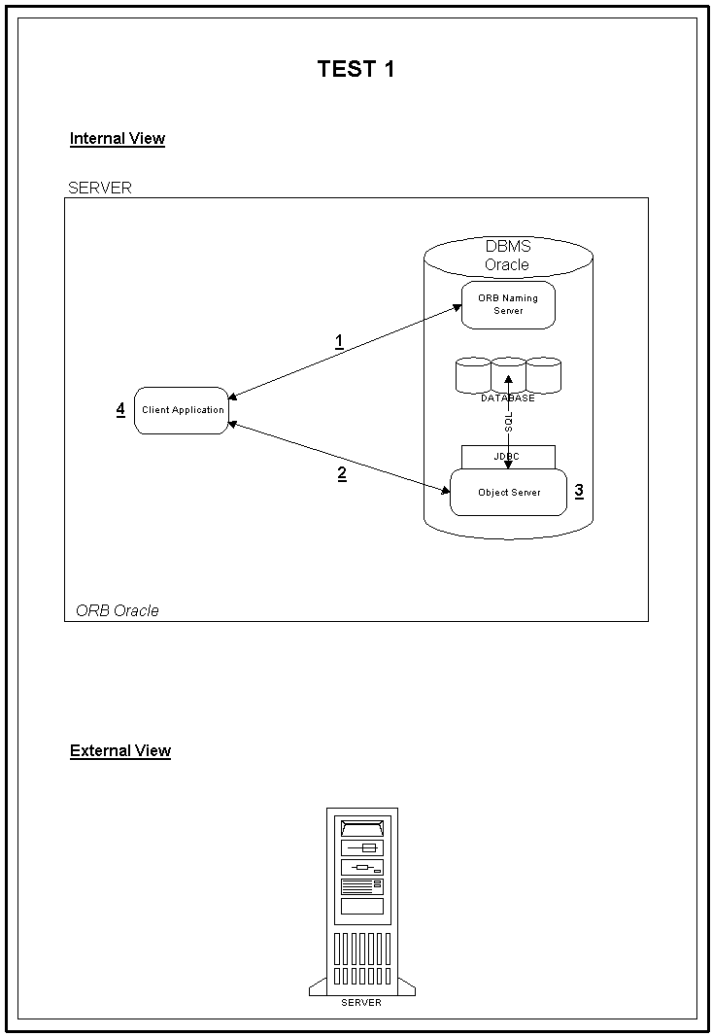Figure-1

Test 2

This Client/Server Application has JServer ORB Naming Server, Object Server and Oracle8i running at Server Machine and Client Application running at Client Machine. In this case, there is network traffic between client and server. Figure-2 shows, in a schematic way, how the application works.

The Application behavior follows the below steps:
-  Client Application asks the JServer ORB Naming Server the reference of Object Server.
-  Client Application sends the SQL statement as a parameter and requires directly the Object Server (by its reference) to query the database.
-  Object Server queries the database, using JDBC Server Side Internal Driver, converts the result set from data type ‘any’ to the original basic data type and returns the converted data to Client Application.
-  Client Application receives the results and performs the response time calculations.

The Response Time is divided in CORBA and Network (= from  to  minus ) and Server (). Two SQL statements were used to perform the tests, the difference between then is the amount of data. The test was done by repeating the same operation 5 times, as a loop, to compare the response time of the fist time with the others, because at the first time the result set data is still in the disks and at the second time it is into the cash memory.

First statement: select * from equipment where dscname = 'dcpsvac1'
Catch 385 rows that match 40 Kbytes.
CORBA and Network time Server time
182 ms 497 ms
202 ms 448 ms
260 ms 450 ms
262 ms 450 ms
221 ms 451 ms

Second statement: select * from equipment
Catch 14.256 rows that match 1.4 Mbytes.
CORBA and Network time Server time
6142 ms 19853 ms
7644 ms 21420 ms
6137 ms 19056 ms
5755 ms 21013 ms
6673 ms 20404 ms
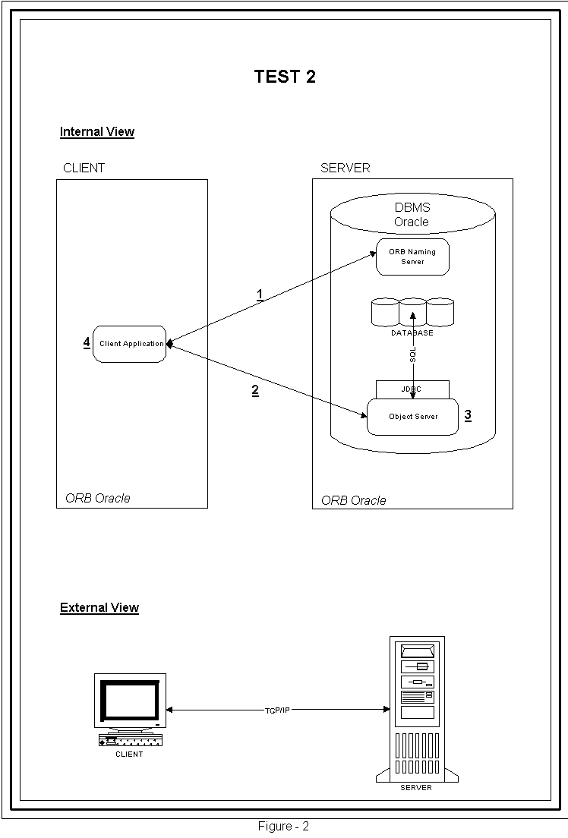

Test 3

This application tests INTEROPERABILITY between JServer ORB and ORBacus. For this test we configured three machines, two of them are Client Machines and one is a Server Machine, the communication protocol is TCP/IP.
This Client/Server Application has JServer ORB Naming Server, Object Server and Oracle8i running at Server Machine (under JServer ORB environment), the first Client Application running at one Client Machine (under JServer ORB environment) and the second Client Application running at another one Client Machine (under ORBacus environment). In this case, there is network traffic between clients and server. Figure-3 shows, in a schematic way, how the application works.

The Application behavior follows the below steps:
-  First Client Application asks the JServer ORB Naming Server the reference (IOR) converted to String of Object Server and starts a method that keep the Object Server active.
-  Second Client Application sends the SQL statement as a parameter and requires, by the IOR, directly the Object Server (already active) to query the database.
-  Object Server tries to query the database using JDBC Server Side Internal Driver, converts the result set from data type ‘any’ to the original basic data type and returns the converted data to Client Application, but receives the exception from JServer ORB:
org.omg.CORBA.NO_PERMISSION:
at java.lang.Exception.<init>(Compiled Code)
at java.lang.RuntimeException.<init>(Compiled Code)
at org.omg.CORBA.SystemException.<init>(Compiled Code)
at org.omg.CORBA.NO_PERMISSION.<init>(Compiled Code)
at com.ooc.CORBA.Util.unmarshalSystemException(Compiled Code)
at com.ooc.CORBA.Util.unmarshalSystemExceptionThrow(Compiled Code)
at com.ooc.CORBA.GIOPClient.request(Compiled Code)
at com.ooc.CORBA.Request.invoke(Compiled Code)
at db.StubForDatabase.executeQuery(Compiled Code)
at orbClient.main(Compiled Code)
It means that it was possible to access and run the Object Server’s method that queries the database but the JDBC connection and execution is forbidden. This happens because the JServer ORB is not 100% compliant with standard CORBA, as explained below:
“You can interoperate with Oracle8i from a client that uses another vendor's ORB. To do so, the vendor must provide the functionality that Oracle8i uses by being part of the database: functions such as session-based connections, extended CosNaming functions, and the login protocol. To provide this functionality, your ORB vendor must work with Oracle's Product Management to provide libraries for you.” - Oracle8i Enterprise JavaBeans and CORBA Developer's Guide - Release 2 (8.1.6)

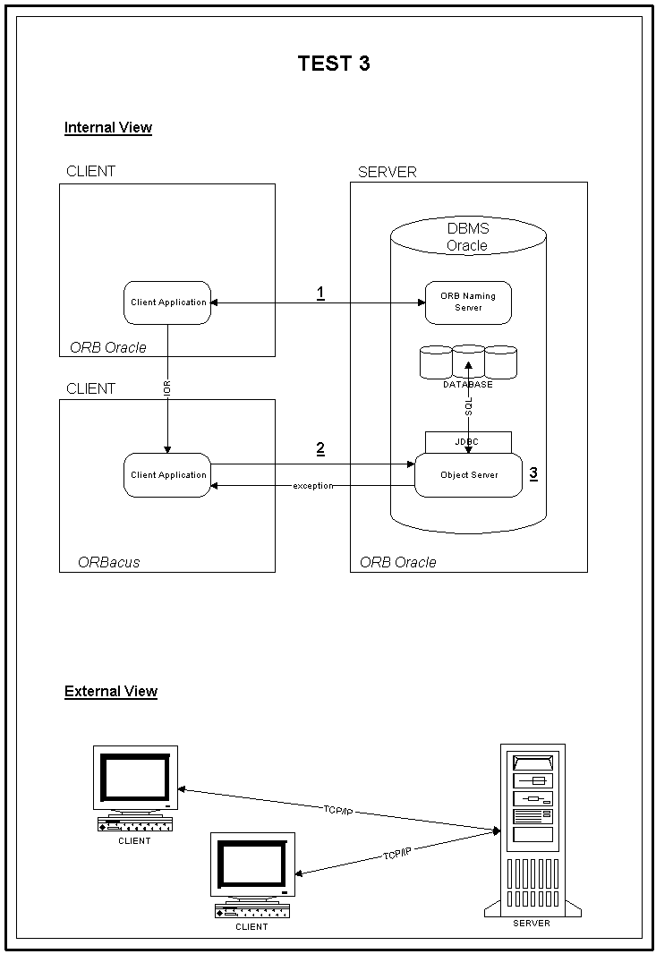Figure-3

Test 4

This Client/Server Application has Object Server, Client Application and Oracle8i running at one Server Machine and ORBacus Naming Server running at another Server Machine. In this case, there is network traffic between the servers. Figure-4 shows, in a schematic way, how the application works.

The Application behavior follows the below steps:
-  Object Server publishes its reference (IOR) at the ORBacus Naming Server.
-  Client Application asks the ORBacus Naming Server the reference of Object Server.
-  Client Application sends the SQL statement as a parameter and requires directly the Object Server (by its reference) to query the database.
-  Object Server queries the database, using JDBC OCI Driver, converts the result set from data type ‘any’ to the original basic data type and returns the converted data to Client Application.
-  Client Application receives the results and performs the response time calculations.

The Response Time is divided in CORBA and Network (= from  to  minus ) and Server (). Two SQL statements were used to perform the tests, the difference between then is the amount of data. The test was done by repeating the same operation 5 times, as a loop, to compare the response time of the fist time with the others, because at the first time the result set data is still in the disks and at the second time it is into the cash memory.

First statement: select * from equipment where dscname = 'dcpsvac1'
Catch 385 rows that match 40 Kbytes.
CORBA and Network time Server time
221 ms 244 ms
128 ms 141 ms
119 ms 140 ms
116 ms 131 ms
109 ms 123 ms

Second statement: select * from equipment
Catch 14.256 rows that match 1.4 Mbytes.
CORBA and Network time Server time
7008 ms 5714 ms
6835 ms 5645 ms
6436 ms 5240 ms
6295 ms 5220 ms
6333 ms 5292 ms
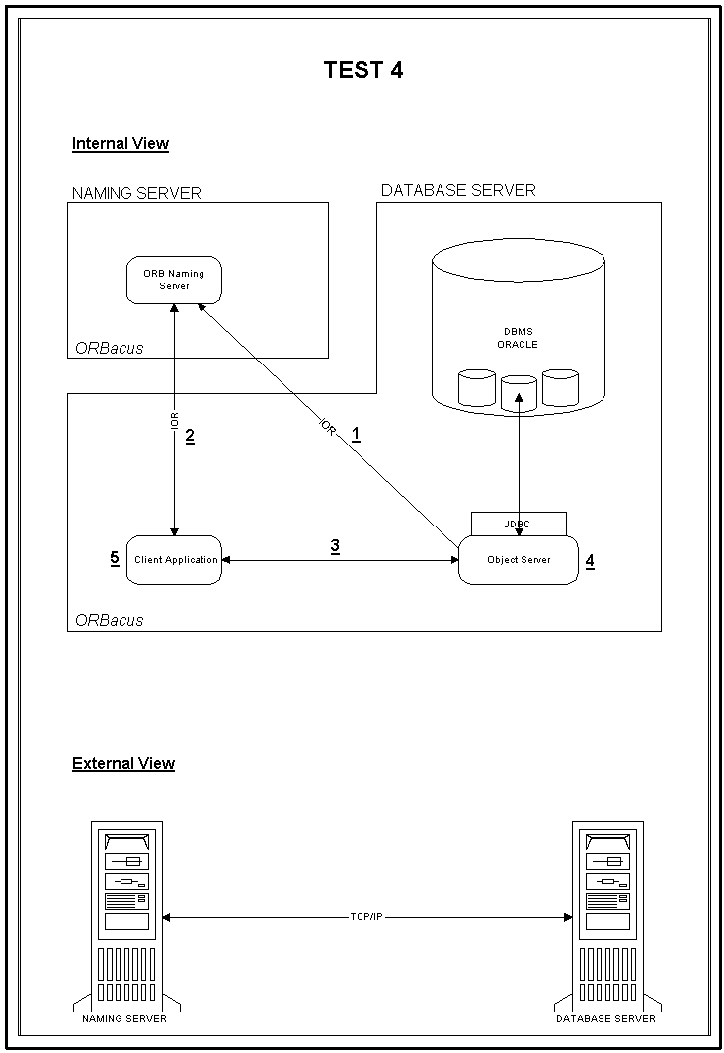Figure-4

Test 5

This Client/Server Application has Object Server and Oracle8i running at one Server Machine, ORBacus Naming Server running at another Server Machine and Client Application running at Client Machine. In this case, there is network traffic between client and servers. Figure-5 shows, in a schematic way, how the application works.

The Application behavior follows the below steps:
-  Object Server publishes its reference (IOR) at the ORBacus Naming Server.
-  Client Application asks the ORBacus Naming Server the reference of Object Server.
-  Client Application sends the SQL statement as a parameter and requires directly the Object Server (by its reference) to query the database.
-  Object Server queries the database, using JDBC OCI Driver, converts the result set from data type ‘any’ to the original basic data type and returns the converted data to Client Application.
-  Client Application receives the results and performs the response time calculations.

The Response Time is divided in CORBA and Network (= from  to  minus ) and Server (). Two SQL statements were used to perform the tests, the difference between then is the amount of data. The test was done by repeating the same operation 5 times, as a loop, to compare the response time of the fist time with the others, because at the first time the result set data is still in the disks and at the second time it is into the cash memory.

First statement: select * from equipment where dscname = 'dcpsvac1'
Catch 385 rows that match 40 Kbytes.
CORBA and Network time Server time
444 ms 125 ms
394 ms 128 ms
430 ms 122 ms
388 ms 124 ms
388 ms 127 ms

Second statement: select * from equipment
Catch 14.256 rows that match 1.4 Mbytes.
CORBA and Network time Server time
16544 ms 5183 ms
16554 ms 5268 ms
java.lang.OutOfMemoryError (at client)

This exception can be solved by customizing some basic memory parameters.
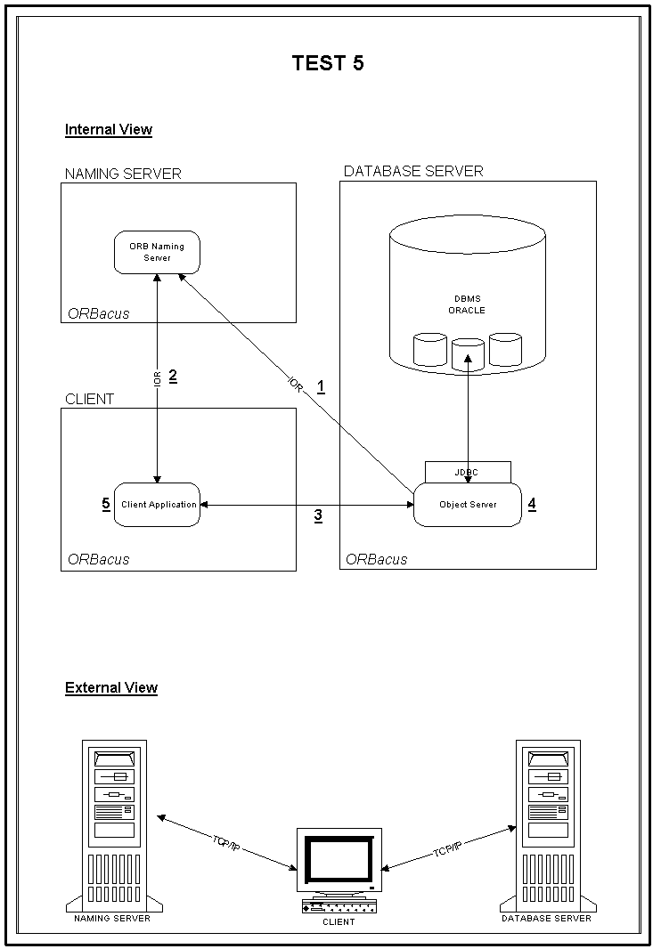Figure-5
Test 6

This Client/Server Application has the Object Server running at one Server Machine, ORBacus Naming Server running at other Server Machine, Oracle8i running at another Server Machine and Client Application running at Client Machine. In this case, there is network traffic between client and servers. Figure-6 shows, in a schematic way, how the application works.

The Application behavior follows the below steps:
-  Object Server publishes its reference (IOR) at the ORBacus Naming Server.
-  Client Application asks the ORBacus Naming Server the reference of Object Server.
-  Client Application sends the SQL statement as a parameter and requires directly the Object Server (by its reference) to query the database.
-  Object Server queries the database, using JDBC Thin Driver, converts the result set from data type ‘any’ to the original basic data type and returns the converted data to Client Application.
-  Client Application receives the results and performs the response time calculations.

The Response Time is divided in CORBA and Network (= from  to  minus ) and Server (). Two SQL statements were used to perform the tests, the difference between then is the amount of data. The test was done by repeating the same operation 5 times, as a loop, to compare the response time of the fist time with the others, because at the first time the result set data is still in the disks and at the second time it is into the cash memory.

First statement: select * from equipment where dscname = 'dcpsvac1'
Catch 385 rows that match 40 Kbytes.
CORBA and Network time Server time
612 ms 553 ms
561 ms 510 ms
507 ms 570 ms
508 ms 565 ms
549 ms 554 ms

Second statement: select * from equipment
Catch 14.256 rows that match 1.4 Mbytes.
CORBA and Network time Server time
java.lang.OutOfMemoryError (at client)

This exception can be solved by customizing some basic memory parameters.

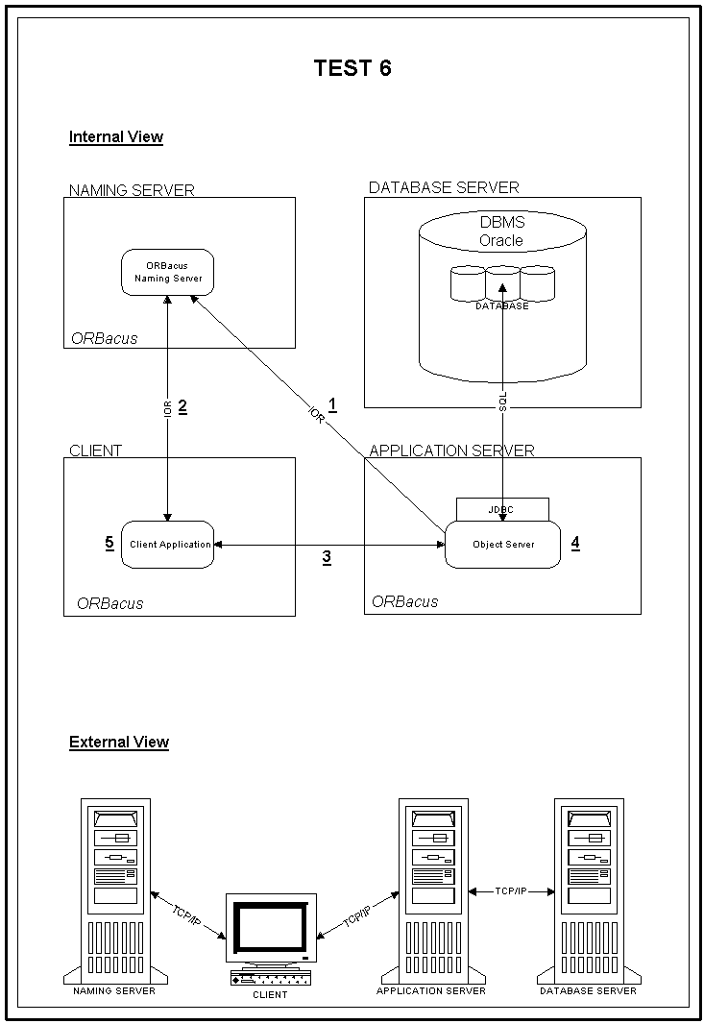Figure-6

Conclusion
Many distributed systems have been built as a multi tier system. This system has a client program communicating with a server program by TCP/IP communication protocol. Typically, the user interface is in the client, and the server is there to process data and to manipulate a database. Nevertheless, there are additional tiers interposed: they are there to handle the application logic leaving the client just to handle the user interface. These tiers have been written in many languages and many platforms, therefore it is necessary to have a portable and malleable environment. Furthermore, the performance is an important success factor of this system.
Based on the results of the performance and interoperability tests, the best solution for the system is:
- ORB: ORBacus 3.3 for Java,
- DBMS: Oracle8i 8.1.6,
- Communication Protocol: TCP/IP,
- Communication Driver: JDBC. (between application and database).

It must be clear that this is the best solution for this specific environment, because if there is not need to work with LynxOS (which is not supported by Oracle), the difference of response time by itself, is not worth enough to choose one of the two tested CORBA implementations. If such limitations are not present, then Oracle ORB is better choice than ORBacus.

On the other hand, JServer ORB offers more features and an easiest way of developing, we spend less effort coding, managing and handling the applications of the system. However, some of these features become JServer ORB not 100% CORBA compliant.

